**CITIZEN CARD PORTAL**

A PROJECT REPORT SUBMITTED IN PARTIAL FULFILMENT OF REQUIREMENT

FOR THE AWARD OF THE DEGREE

**MASTER OF COMPUTER APPLICATIONS (MCA)**

**OF**

**MAHATMA GANDHI UNIVERSITY, KOTTAYAM**

**By**

**MOHAMMAD NOWFAL**

**Reg No: 21PMC167**



**Marian College Kuttikkanam (Autonomous)**

**Peermade, Kerala – 685 531**

**2022**

**CITIZEN CARD PORTAL**

A PROJECT REPORT SUBMITTED IN PARTIAL FULFILMENT OF REQUIREMENT

FOR THE AWARD OF THE DEGREE

**MASTER OF COMPUTER APPLICATIONS (MCA)**

**OF**

**MAHATMA GANDHI UNIVERSITY, KOTTAYAM**

**By**

**MOHAMMAD NOWFAL**

**Reg No: 21PMC167**



**Marian College Kuttikkanam (Autonomous)**

**Peermade, Kerala – 685 531**

**2022**

A Project Report on

**CITIZEN CARD PORTAL**

SUBMITTED IN PARTIAL FULFILMENT OF REQUIREMENT

FOR THE AWARD OF THE DEGREE

**MASTER OF COMPUTER APPLICATIONS**

OF

**MAHATMA GANDHI UNIVERSITY, KOTTAYAM**

**By**

**MOHAMMAD NOWFAL**

**Reg No: 21PMC167**

**Under the guidance of**

**MR ROBINS A KATTOOR**

**Assistant Professor**

PG Department of Computer Applications

Marian College Kuttikkanam (Autonomous)



**Marian College Kuttikkanam (Autonomous)**

**Peermade, Kerala – 685 531**

**2022**

**PG DEPARTMENT OF COMPUTER APPLICATIONS**

**Marian College Kuttikkanam (Autonomous)**

**MAHATMA GANDHI UNIVERSITY, KOTTAYAM**

**KUTTIKKANAM – 685 531, KERALA.**

**CERTIFICATE**

This is to certify that the project work entitled

**“CITIZEN CARD PORTAL”**

is a bonafide record of work done by

**MOHAMMAD NOWFAL**

**Reg. No. 21PMC167**

In partial fulfillment of the requirements for the award of Degree of

**MASTER OF COMPUTER APPLICATIONS [MCA]**

During the academic year 2021 - 2022.

**Mr. Robins A Kattoor Mr. Win Mathew John**

**Assistant Professor Head of the Department**

PG Department of Computer ApplicationsPG Department of Computer Applications Marian College Kuttikkanam (Autonomous) Marian College Kuttikkanam (Autonomous)

Examiner’s Signature

**ACKNOWLEDGEMENT**

First of all, I thank the “God Almighty” for his immense grace and blessings in my life and at each stage of my project work.

I express my sincere gratitude to Rev. Fr. Roy Abraham P, Principal, Marian College Kuttikkanam (Autonomous), Dr. Mendus Jacob, Director, PG Department of Computer Applications for the support given throughout the project work

I extend my gratitude to Mr. Win Mathew John, HOD, PG Department of Computer Applications, who is a constant source of inspiration and whose advice helped me to complete this project work successfully.

I express my deep sense of gratitude to my project guide, MR ROBINS A KATTOOR Associate Professor/Assistant Professor, PG Department of Computer Applications, for his/her profound guidance for the successful completion of this project work.

With great enthusiasm, I express my gratitude to all the faculty members of the PG Department of Computer Applications for their timely help and support.

Finally I express my deep appreciation to all my friends and family members for the moral support and encouragement they have given to complete this project work successfully.

**MOHAMMAD NOWFAL**

**ABSTRACT**

The main aim of developing this project is to apply citizen card to by just on click and reduce the time consumption. User can register, login, update their profile, change password, upload documents and details and view status. User can apply for the card after completing the registration and login process. User need to upload the necessary documents needed for applying the citizen card.

The Citizen Card Portal will be used to minimize the time and resource by maintaining the details of the user. The resources which are minimised are workforce, money, papers, etc. The system is user friendly and will help the user. The Citizen Card Portal will reduce the burden of user reducing the time standing in front of the offices for applying a citizen card.

In this web application mainly used software are processor: intel corei5, Operating System: Windows 11, Back End: MYSQL, Frond End: PHP, Software used: Visual studio code. The testing methods used are Unit Testing, Integration Testing, Validation Testing, System Testin

**TABLE OF CONTENTS**

|  |  |  |
| --- | --- | --- |
| **SI NO** | **TITLE** | **PAGE** |
| **1** | **INTRODUCTION** | **1** |
|  | 1.1 OVERVIEW OF THE PROJECT | 2 |
| **2** | **SYSTEM STUDY** | **3** |
|  | 2.1 BACKGROUND ANALYSIS | 4 |
|  | 2.2 EXISTING SYSTEM | 4 |
|  | 2.3 PROPOSED SYSTEM | 4 |
|  | 2.4 TECHNOLOGIES USED FOR SYSTEM STUDY | 5 |
| **3** | **SYSTEM ANALYSIS** | **6** |
|  | 3.1 FEASIBILITY STUDY | 7 |
|  | 3.2 REQUIREMENT SPECIFICATION | 8 |
| **4** | **SYSTEM DESIGN** | **9** |
|  | 4.1 MODULE SPECIFICATION | 10 |
|  | 4.2 DATABASE DESIGN | 11 |
|  | 4.3 UML DIAGRAMS | 12 |
| **5** | **SYSTEM DEVELOPMENT** | **13** |
|  | 5.1 SOFTWARE ENVIRONMENT | 14 |
|  | 5.2 SOFTWARE STACK | 15 |
| **6** | **SYSTEM TESTING** | **16** |
|  | 6.1 INTRODUCTION | 17 |
|  | 6.2 TESTING | 17 |
| **7** | **SYSTEM IMPLEMENTATION** | **19** |
|  | 7.1 INTRODUCTION | 20 |
| **8** | **SCOPE FOR FURTHER DEVELOPMENT** | **21** |
| **9** | **CONCLUSION** | **23** |
| **10** | **BIBLIOGRAPHY** | **25** |
| **11** | **APPENDIX** | **27** |

**TABLE INDEX**

|  |  |  |
| --- | --- | --- |
| **SI NO** | **TITLE** | **PAGE** |
| 1 | TABLE 1: REGISTER | 11 |
| 2 | TABLE 2: ADMINLOGIN | 11 |
| 3 | TABLE 3: UPLOAD | 11 |

# 1.INTRODUCTION

* 1. **OVERVIEW OF THE PROJECT**

Citizen Card Portal is the project used for applying citizen card online. The user need not to be visit the government offices or any other computer centers. They can apply the citizen card by uploading necessary documents needed. The admin can delete user and approve or reject the documents and details uploaded by the user. The user can sign up by entering the details of the and login to their corresponding account to apply for the citizen card. After the uploading process is done the user can see the status in view status page that shows that whether the application for the citizen card is approved or not.

# 2.SYSTEM STUDY

**2.1 BACKGROUND ANALYSIS**

The internet has been developing for three decades eventually during the mid-nineties, the commercial use of the internet triggered high expectations in both executives and investors. Citizen card portal can be closely connected to the environment and it can be very useful for the society.

**2.2 EXISTING SYSTEM**

The users goes to the government offices or any other computer centers to apply for the citizen card. So a lot of time is consumed and the users gets tired. If the user forgot to take any document then after collecting that document once again he/she need to go the government offices or other computer centers The complete process depends on the physical interactions.

**2.3 PROPOSED SYSTEM**

The Citizen Card Portal is easy to use and apply card. The users can apply card by a single click. Before it is done, the users need to create and login account and fill the details asked in that page fields. The user can be able to view the status of the application that he has uploaded. The main goal of this application is to apply card online to all the people without going anywhere.

1. Friendly user interface.
2. Time saving.

**2.4 TECHNOLOGIES USED FOR SYSTEM STUDY**

The technologies used to develop this portal are:

* PHP
* MYSQL
* HTML
* CSS

**PHP:**

PHP is a server-side language that can be used in conjunction with a database to create

dynamic web pages. By the word "dynamic" it allows you to input or query data from a web page. These aren't the only things PHP allows you to do interaction with databases are a key feature of server-side languages.

**MYSQL:**

MySQL is an [open-source](https://en.wikipedia.org/wiki/Open-source_software) [relational database management system](https://en.wikipedia.org/wiki/Relational_database_management_system) (RDBMS). Its name is a combination of "My", the name of co-founder [Michael Widenius](https://en.wikipedia.org/wiki/Michael_Widenius)'s daughter, and "[SQL](https://en.wikipedia.org/wiki/SQL)", the abbreviation for [Structured Query Language](https://en.wikipedia.org/wiki/Structured_Query_Language). A [relational database](https://en.wikipedia.org/wiki/Relational_database) organizes data into one or more data tables in which data types may be related to each other; these relations help structure the data. SQL is a language programmers use to create, modify and extract data from the relational database, as well as control user access to the database.

**HTML:**

Hypertext Markup Language is the standard markup language for documents designed to be displayed in a web browser. It can be assisted by technologies such as Cascading Style Sheets and scripting languages such as JavaScript, ASP and PHP.

**CSS:**

Cascading Style Sheets is a style sheet language used for describing the presentation of a document written in a markup language like HTML. CSS is a cornerstone technology of the World Wide Web, alongside HTML and JavaScript.

# 3.SYSTEM ANALYSIS

**3.1 FEASIBILITY STUDIES**

Feasibility is an important phase in the software development process it enables the developers to have an assessment of the product being developed. It refers to the feasibility study of the product in terms of outcomes of the product, operational required for implementing it.

Feasibility study should be performed on the basic of various criteria and parameters. Feasibility study includes consideration of all the possible ways to provide a solution to the given problem. The proposed solution should satisfy all the user requirements and should be flexible enough so that future changes can be easily done based on the future upcoming requirements.

* **Economical Feasibility**

This is a very important aspect to be considered while developing a project. We decided the technology based on minimum possible cost factor.

* All hardware and software cost has to be borne by the organization.
* Overall we have estimated that the benefits the organization is going to receive from the proposed system will surely overcome the initial costs and the later on running cost for system.
* **Technical Feasibility**

This included the study of function, performance and constraints that may affect the ability to achieve an acceptable system. For this feasibility study, we studied complete functionality to be provided in the system, as described in the System Requirement Specification (SRS), and checked if everything was possible using different type of frontend and backend platforms.

* **Operational Feasibility**

No doubt the proposed system is fully GUI based that is very user friendly and all inputs to be taken all self-explanatory even to a layman. Besides, a proper training has been conducted to let know the essence of the system to the users so that they feel comfortable with new system. As far our study is concerned the clients are comfortable and happy as the system has cut down their loads and doing.

**3.2 REQUIREMENT SPECIFICATION**

Requirement Analysis is the process of defining the expectations of the users of an application that is to be built or modified. It involves all the tasks that are conducted to identify the needs of different stakeholders.

1. **ADMIN**

* Admin can login.
* Admin can delete users.
* Can see the total number of requests.
* Can approve or reject the application.

1. **USERS**

* User can register.
* User can login.
* User can update profile.
* User can upload details and documents.
* User can view status.

# 4.SYSTEM DESIGN

* 1. **MODULE SPECIFICATION**
* **Different Modules**
* **ADMIN**
* **Login**

In login, admin can enter the username and password and can login to the admin page.

* **Delete Users**

Admin can delete or remove the user with the a specific id called user id.

* **View Requests**

Admin can view the requests from user and approve or decline the request.

* **Logout**

Admin can logout from the site

* **USERS**
* **Signup**

User can create an account by entering the specified details.

* **Login**

User can login using there corresponding username and password.

* **Update Profile**

User can update the profile.

* **Upload Details**

User can upload the details and documents.

* **View Status**

User can view the status of the application uploaded.

* **Logout**

User can logout from the site.

* 1. **DATABASE DESIGN**

**TABLE-1 REGISTER**

|  |  |  |  |
| --- | --- | --- | --- |
| **FIELD NAME** | **DATATYPE** | **SIZE** | **CONSTRAINT** |
| USERNAME | VARCHAR | 20 | NOT NULL |
| PASSWORD | VARCHAR | 20 | NOT NULL |
| EMAIL | VARCHAR | 30 | NOT NULL |

**TABLE-2 ADMIN LOGIN**

|  |  |  |  |
| --- | --- | --- | --- |
| **FIELD** | **DATATYPE** | **SIZE** | **CONSTRAINT** |
| USERNAME | VARCHAR | 20 | NOT NULL |
| PASSWORD | VARCHAR | 20 | NOT NULL |

**TABLE-3 UPLOAD**

|  |  |  |  |
| --- | --- | --- | --- |
| **FIELD** | **DATATYPE** | **SIZE** | **CONSTRAINT** |
| FIRSTNAME | VARCHAR | 20 | NOT NULL |
| LASTNAME | VARCHAR | 20 | NOT NULL |
| ADDRESS | VARCHAR | 40 | NOT NULL |
| PHONE | INT | 10 | NOT NULL |
| MARITAL_STATUS | VARCHAR | 20 | NOT NULL |

* 1. **UMLDIAGRAM**

USER

ADMIN

# 5.SYSTEM DEVELOPMENT

**5.1 SOFTWARE ENVIRONMENT**

Software requirements for the installation and smooth functioning of this project could be configured based on the requirements needed by the component of the operating environment that works as front-end system here we suggest minimum configuration for the both hardware and software components. Working off with this software is requirements concrete on system environments.

**Software Requirement:**

* Processor: intel core i5
* Operating System: Windows 11
* Back End: MYSQL
* Front End: PHP
* Software used: Visual studio code

**5.2 SOFTWARE STACK**

A software stack is a collection of independent components that work together to support the execution of an application. The components, which may include an operating system, architectural layers, protocols, run-time environments, databases and function calls, are stacked one on top of each other in a hierarchy. Typically, the lower-level components in the hierarchy interact with hardware, while the higher-level components in the hierarchy perform specific tasks for the end user. Components communicate directly with the application through a series of complex instructions that traverse the stack.

**HTML**- is a revision of the Hypertext Markup Language (HTML), the standard programming language for describing the contents and appearance of Web page.

**CSS** -This definition explains the meaning of CSS (cascading style sheets) and how using them with HTML pages is a user interface (UI) development best practice that complies with the separation of concerns design pattern.

**MySQL**- MySQL is a viable open-source database implementation for PHP web applications.

**PHP**- PHP is a server-side language that can be used in conjunction with a database to create dynamic web pages.

# 6.SYSTEM TESTING

**6.1 INTRODUCTION**

Testing enhances the integrity of a system by identifying deviations in design and development of the expected end product. It should focus more on the error-prone areas of the application. This help in the prevention of errors in a system and builds confidence that the system will work without error after testing. It is the process of executing a program with the intent of finding an error. Testing also adds value to the product by conforming to the user requirements. Testing verifies that software deliverable conforms precisely and design phases.

**6.2 TESTING**

The overall strategy for testing “Citizen card portal” application is described as follows. The four different methods are used to test the software.

* **Unit testing**

The modules of the project “Citizen card portal” are tested separately. Unit testing focuses verification efforts even in the smallest unit of software design in each module. This is known as “Module Testing”. This testing is carried out in the programming style itself. In this testing each module is focused to work satisfactorily as regard to expected output from the module. There are some validation checks for the fields. Unit testing gives stress on the modules of application independently of one another, to find errors.

* **Integration testing**

In this, whole modules of the project “Citizen card portal” are connected and tested. Data can be lost across an interface, one module can have an adverse effect on the other sub-functions, when combined may not produce the desired functions. Integrated testing is the systematic testing to uncover the errors within the interface. This testing is done with simple data and the developed system has run successfully with this simple data. The need for integrated system is to find the overall system performance.

* **Validation testing**

Validation testing is a process of obtaining the right amount of processing capability of the software “online pharmacy management system”. The process of evaluating software during the development process or at the end of the development process is to determine whether it satisfies specified s/w requirements. Validation Testing ensures that the product actually meets the client's needs. It can also be defined as to demonstrate that the product fulfills its intended use when deployed on appropriate environment. Advantages of validation are, during verification if some defects are missed then during validation process it can be caught as failures.

* **System testing**

The implementation of a computer-based system requires that test data to be prepared and that the system and its elements be tested in a planned structured manner. The computer program component is a major sub-system of the computer-based information system and particular attention should be given to the testing of this system element as it is developed in a software development project, errors can be injected at any stage during development. Each will discuss different techniques for detecting and eliminating errors that originate in that phase. In software the use of testing is not limited to the testing phase. Here I have tested all the modules in my project separately and run successfully.

# 7.SYSTEM IMPLEMENTATION

**7.1 INTRODUCTION**

A product software implementation method is a blueprint to get users and/or organizations running with a specific software product. The method is a set of rules and views to cope with the most common issues that occur when implementing a software product: business alignment from the organizational view and acceptance from human view. The implementation of product software, as the final link in the deployment chain of software production, is in a financial perspective of a major issue. It is stated that the implementation of (product) software consumes up to 1/3 of the budget of a software purchase (more than hardware and software requirements together).

# 8.SCOPE FOR FURTHER

**DEVELOPMENT**

Include more machine learning into our system that provide a more predictable outcomes like we got the review of where the course will slow down where the student understanding difficulties,

• Including more features like integrating multiple modules rather than video tutorials.

• Integrated with supporting mentors.

• Providing help desk features.

# 9.CONCLUSION

At the end of the project. Though we cannot say, it is perfect system without bugs and errors, we tried our level best for minimizing errors and making the system more user friendly for the purpose. Our project is only a humble venture to satisfy the needs to manage their project work. Several user-friendly coding has also adopted. This package shall prove to be a powerful package in satisfying all the requirements of the college. The objective of software planning is to provide a frame work that enables the admin to make reasonable estimated made within a limited time frame at the beginning of the software project and should be updated regularly as the progresses.

**This Report Contains…**

• A description of the background and context of the project and its relation to work

already done in the area.

• Made statement of the aims and objectives of the project.

• The description of Purpose, Scope, and applicability.

• We define the problem on which we are working in the project.

• We describe the requirement Specifications of the system and the actions that can be

done on these things.

• We understand the problem domain and produce a model of the system, which

describes operations that can be performed on the system.

• We included features and operations in detail, including screen layouts.

• We designed user interface and security issues related to system.

• Finally, the system is implemented and tested according to test cases.

# 10.BIBLIOGRAPHY

\

**WEBITES:**

[PHP Tutorial (w3schools.com)](https://www.w3schools.com/PHP/)

[CSS Tutorial (w3schools.com)](https://www.w3schools.com/CSS/)

[HTML Tutorial (w3schools.com)](https://www.w3schools.com/HTML/)

# 11.APPENDIX

**SAMPLE CODE:**

<html>

<head>

<title>Upload Details</title>

<link rel="stylesheet" href="upload_details.css">

</head>

<body>

<h1>Upload Details</h1>

<?php session_start(); $user_id=$_SESSION['user_id']; ?>

<form action="upload_details.php" method="post">

<input type="hidden" name="user_id" value="<?php echo $user_id; ?>" readonly >

<div class="main">

<p>

First Name:<br>

<input type="text" name="firstname" required="">

</p>

<p>

Last Name:<br>

<input type="text" name="lastname" required="">

</p>

<p>

Address:<br>

<input type="text" name="address" required="">

</p>

<p>

Contact Number:<br>

<input type="number" name="phone" required="">

</p>

<p>

Marital Status:<br>

<select name="marital_status">

<option value="Married">Married</option>

<option value="Unmarried">Unmarried</option>

</select>

</p>

</div>

<input type=submit value="Submit">

</form>

</body>

</html>

**SCREENSHOTS:**

**LAUNCHING**

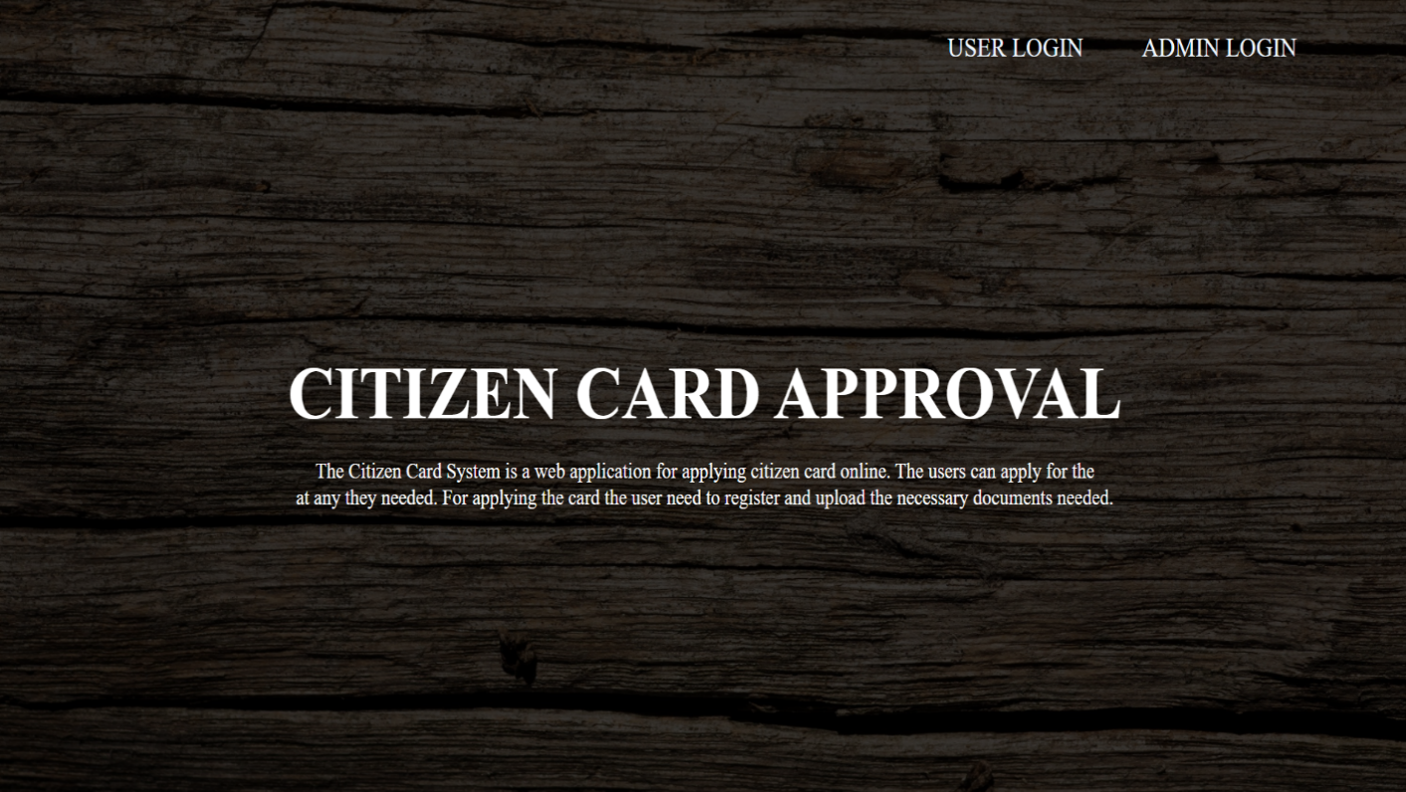

**ADMIN LOGIN**

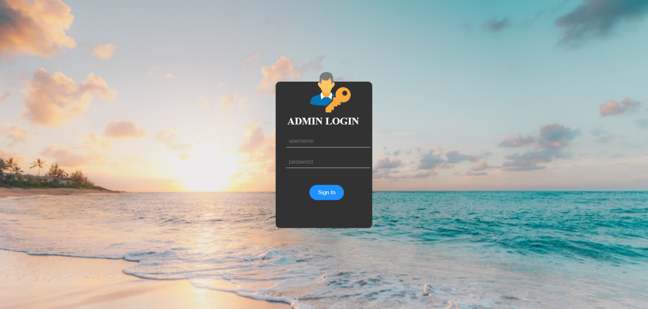

**ADMIN HOME**

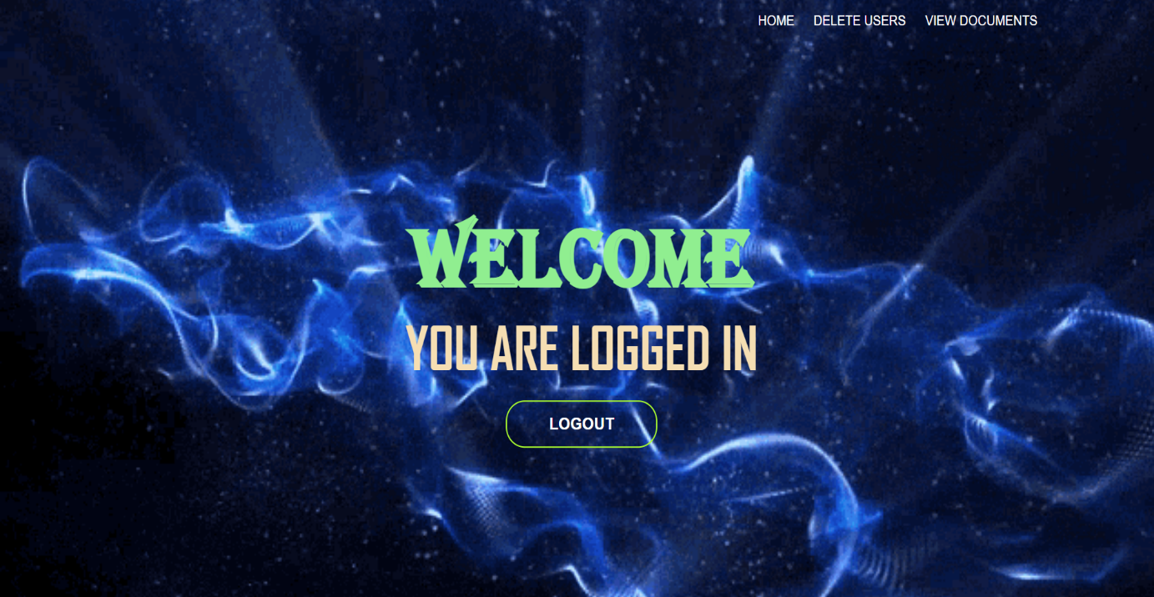

**DELETE USER**

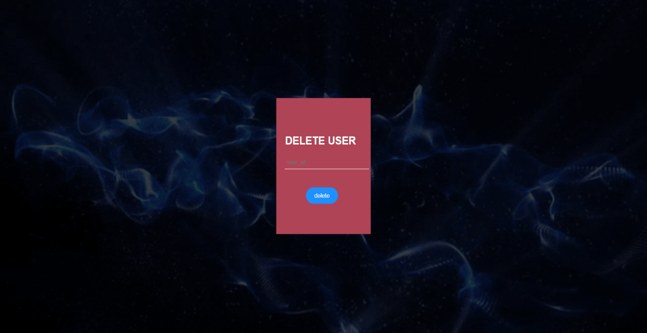

**REGISTER**

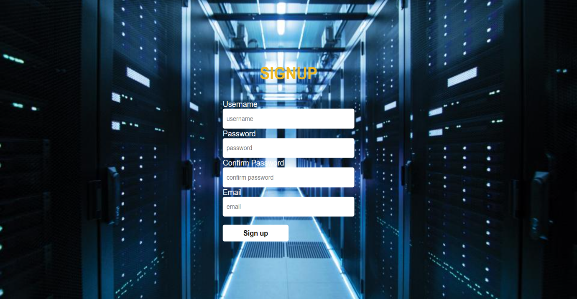

**USER LOGIN**

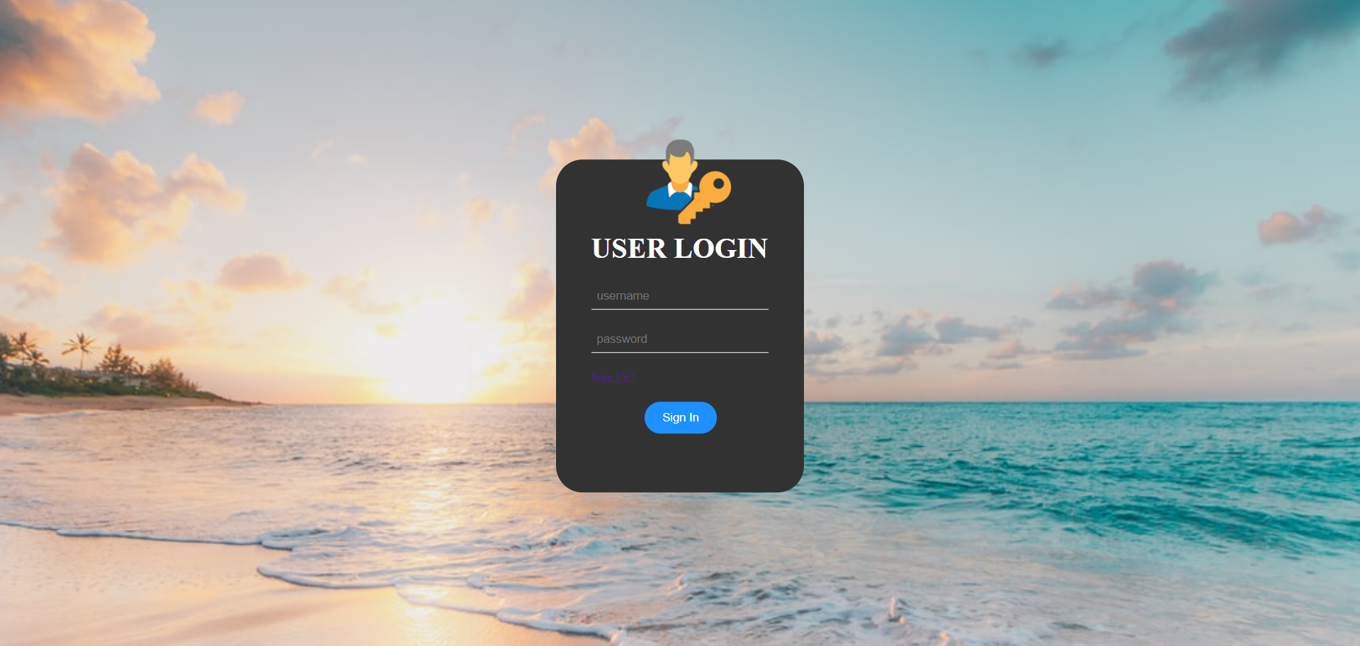

**HOME**

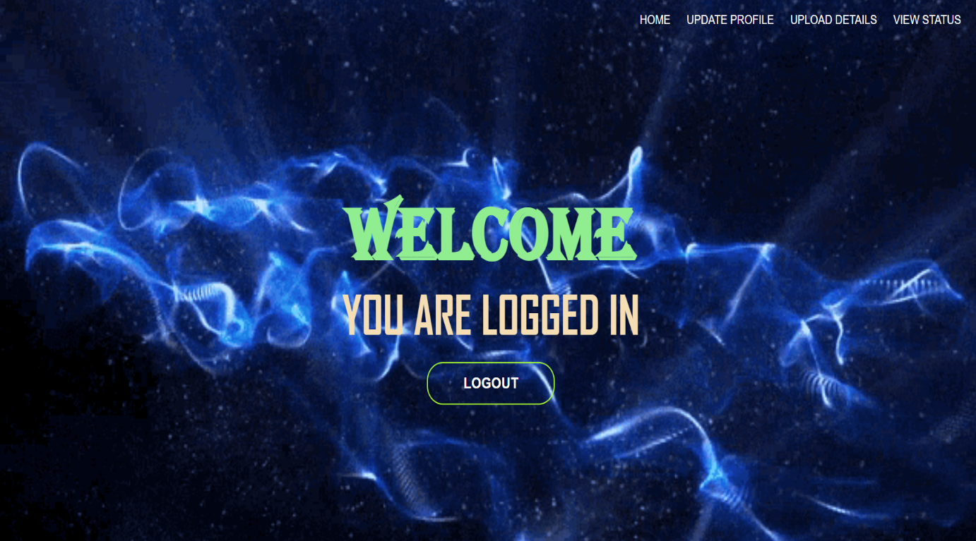

**UPDATE PROFILE**

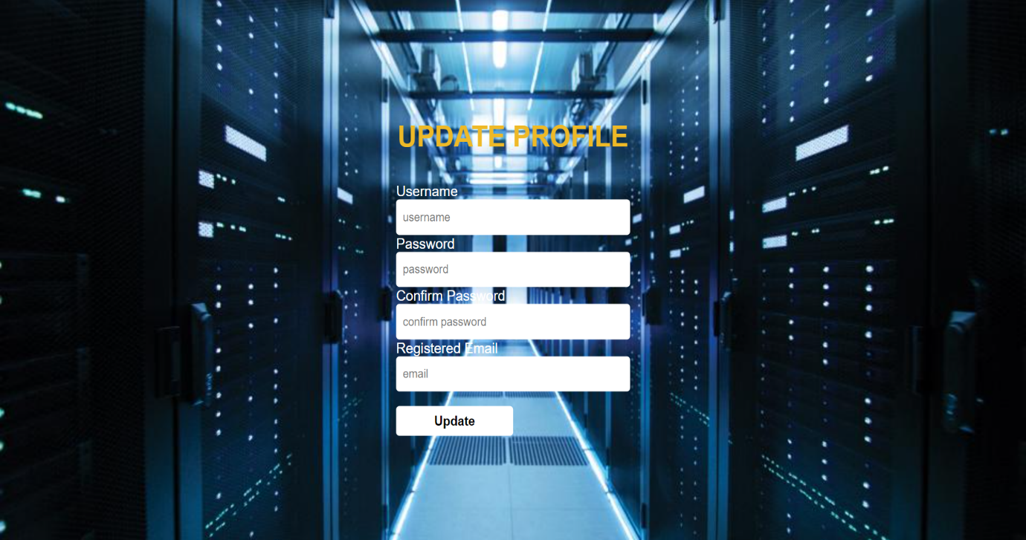

**UPLOAD DETAILS**

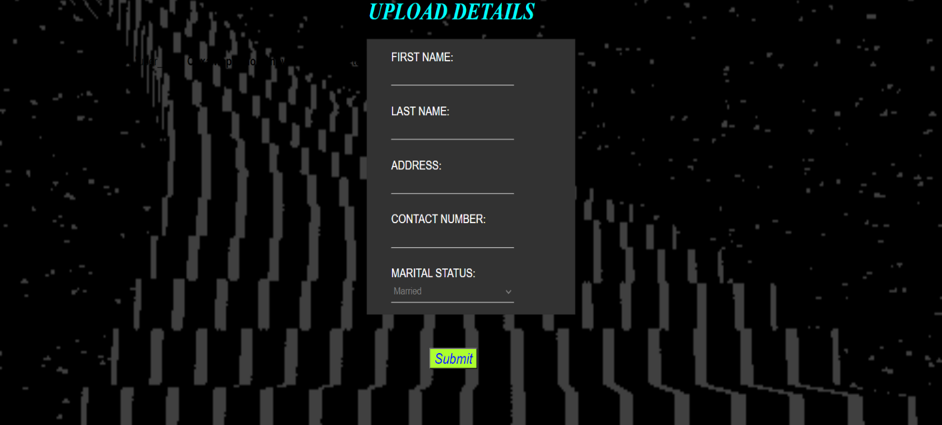

**VIEW REQUESTS**

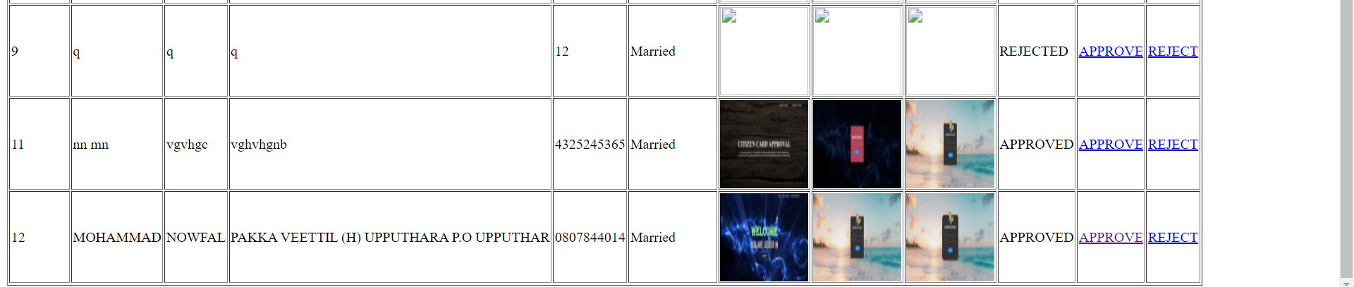

**VIEW STATUS**

